An Efficient Flood Identification and Cautioning System Using IoT and ML

Lalu Prasad M Manasa C H Resham Sundar Kumar

School of C and IT School of C and IT School of C and IT

REVA University REVA University REVA University

Bangalore,India Bangalore,India Bangalore,India

[laluprasad.715364@gmail.com](mailto:laluprasad.715364@gmail.com) [ch.manasachowdary@gmail.com](mailto:ch.manasachowdary@gmail.com) resham.sundar@gmail.com

Vinay Kumar M

School of C and IT

REVA University

Bangalore,India

vinaykumarm@reva.edu.in

--------------------------------------------------------------------**************----------------------------------------------------------------

***ABSTRACT****–* ***Flood is an inevitable naturally occurring phenomenon that causes high traffic flows and can also cause substantial property and livelihood harm***. ***There is a need for an efficient system that could mitigate floods and reduce the flood casualties***. ***This is why we have built a flood warning system to track rising water in different regions using IoT and a prediction system in which we collect data sets to predict flooding in a dam using ML. IoT is the latest increasingly expanding technology in its use. The Internet of Things Technology(IoTs) is greatly influencing the development of early warning systems, while the methods of machine learning (ML) have greatly contributed to the advancement of prediction systems which provide better performance and cost. The flood height is set by subtracting the sensor peak as regards the ground minus the sensed range between the sensor and the flood water.Water level height alerts will be provided to alert the authorities on the website. The data uploaded to the website will also be used to train our model to predict flooding in the dam. This project aims to realize the security requirements and security architecture of Internet of Things technology for flood identification and cautioning and discusses the demand and overall design of flood management.***

***Keywords: IoT, Flood Prediction, Sensors, Machine Learning,***

**I. INTRODUCTION**

Flood happens as water rises from different water bodies or due excessive rainfall, and it can occur at any given time of the year. Flood is one of the disasters frequently happening due to severe climatic changes.The main aspect of flooding is influenced not only by the environment but also by the climate-affecting human activities. When flooding occurs in an area where people live, the water brings items like buildings, vehicles, furniture and even people along. It can wash houses, trees and much heavier artifacts away.

“An efficient Flood Identification and Cautioning System”, is an intelligent system that closely tracks different natural factors to predict flooding, so that we can take precautions to mitigate flood damage. Natural disasters such as flooding can be catastrophic and can result in property damage and loss of life. The machine uses different natural factors to predict floods to minimize or lessen the flood impacts. The device has WiFi connectivity, and it can quickly access collected data from anywhere using IoT and different datasets are used to forecast the area affected by flooding using machine learning models.

River flood: It is caused due to heavy rainfall, hurricanes, monsoons, tropical storms or glaciers melts that increase the river potential, and its waterways. Blocking the natural flow of the water body due to mud, landslide sludge and other natural outgrowths can also cause these floods. River flooding can also occur on river banks due to unnecessary clearance of the vegetation by humans.

Flash flood: Flash flood is a phenomenon in which water levels increase quickly within a short time. This is caused by excessive and frequent rainfall. When it unexpectedly happens there is no suitable solution for this form of flood.

Coastal flood: Coastal floods occur due to penetration of seawater into the domestic region. It can happen during high tides or storms because of a low pressure situation. The sea level increases abnormally in both cases, triggering floods.

**II. LITERATURE SURVEY**

Reference has been made to papers relating to factors responsible for flooding and current methods used to track floods, and the following conclusion is based on the disadvantages of existing systems.

In [1] (S Vara Kumari, O Sailaja), this framework is built using a Thingspeak application platform for data storage and recovery, and NodeMCU. It sends sms to localities using IFTTT web server.it is not reliable, because it does not use any future prediction techniques.

In [2] (Kalpesh R. Dashpute, Nilesh S. Bawa), a website is broadcast live on the internet and is updated from time to time. Ultrasonic sensor detects water levels, and the controller receives a response. When the water level is above the threshold, people are told via sms. Only one parameter is taken into account, i.e. the water level is not appropriate for successful detection.

In [4] (Sai Sreekar, P.C.Jain), they suggested and introduced a novel concept in this program of automating the dam management mechanism from collecting water level data to monitor the dam gates to prevent flooding.Because all of the systems are being automated, there may be chances of disruption making incorrect predictions.

In [9] (Nova Ahmed, A.K. Azad), this device involves 3 planes and proper operation requires high Internet access that is at risk during flash flooding.

In [10] (Fateen et al), damage caused by heavy rainfall is a problem and this device often relies on cell towers, whose service might not be accessible.

In [11] (Danny Hughes, Phil Greenwood), there is a need for complicated and costly hardware structure and high power consumption too.Since the cost is high it cannot be installed in small towns, villages or cities.

**III. ORGANIZATION**

The Section IV in this paper contains the proposed methodology, which further contains the hardware part and software part. Section V in the paper focuses on our experimentation and discussion of results.The Section VI and VII in this paper contains the conclusion and references respectively.

**IV.** **PROPOSED METHODOLOGY**

An efficient flood identification and cautioning system is parted into two modules, the hardware and the software.

1. ***Hardware Part***

a) Block Diagram

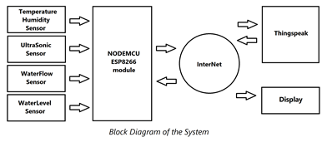

The figure above displays An Efficient Flood Detection and Cautioning System diagram. The above system requires 4 sensors together with nodeMCU, i.e. Temperature and Humidity Sensor, Ultrasonic Sensor, Water Flow Sensor, Water Level Sensor. The temperature and humidity sensor is important to work out the ambient temperature and humidity.

Effectively, ultrasonic sensors measure the quantity of water within the reservoir. Water Flow and Water Level Sensors are important for measuring the river flow and water level from the Dam. We want an external server called Thingspeak to store and retrieve data for the Machine Learning Process and remote access to the info over the web.

b) Ultrasonic sensor

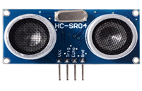

An ultrasonic sensor is a distance measuring sensor which calculates the distance between the sensor and the object using ultrasonic sound waves. Its four pins: Vcc(+5V) pin, Ground pin, Echo pin and Trigger pin. Ultrasonic waves fly faster than visible sound velocities. Ultrasonic sensors have two basic parts: the transmitter and also the receiver. We want this sensor in our Project to know how much water is filled in the reservoir. The echo pin and trigger pin are connected to nodeMCU numbers 16 and 5 pin respectively. The ultrasonic sensor emits the waves of ultrasound that strike every target or obstacle and transmit back to the sensor. Around that time, the sensor measures the period of time between radiated and reflected waves to determine the object's separation.

c) Water Flow Sensor

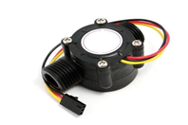

To make note of the amount of water which is let out of the dam and the speed at which the water is let out, we will be using a Water flow sensor. It consists of three pins. Vcc(+5V) pin, Ground pin and data pin. The info pin is patched to the Data2 pin of nodeMCU. Water flow sensor has a small valve through which water can go through. When water runs through the valve, a rotor in the motor takes turns. Using this rotation, the difference is seen within the velocity of the rotor of the motor. This alteration is measured as the result. Thus, the speed of flow of water is computed.

d) Water Level Sensor

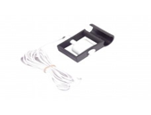

Water Level sensors find the measure of liquids and other fluids and fluidized solids. It's utilized to detect the water level of the river. Water level sensor comprises two pins. Vcc(+5V) pin and Data(info) pin. The info pin of the water level sensor is said to be A0 pin of nodeMCU.

e) Temperature and Humidity Sensor

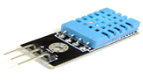

The digital temperature and humidity sensor DHT11 may be a combined sensor that consists of a computed signal which shows us digital measurement of temperature and humidity. It comprises 3 pins. Vcc(+5V) pin, Ground pin and data pin. The communication process will commence when the information line will emit start signals to DHT11, and DHT11 will receive the signals and return a solution signal.

f) ThingSpeak Web Server

ThingSpeak is an open source IOT application and an application program interface to get and push data from sensors and other digital things using the HTTP and MQTT protocol over the web or by means of an Local or Wide Area Network. ThingSpeak can be used to create sensor logging applications, social networks of things so forth. In Thingspeak we use the graphs similarly as numerical displays to watch the info which is refreshed from the sensor by means of the net.Thingspeak can also be used to trigger a precise link if given conditions are met.

***B. Software Part*:**

a) Logistic Regression algorithm

Logistic Regression is one of the machine learning algorithms which mainly focuses on classification problems. It is mainly derived from the concepts of probability and it uses a complicated cost function called the ‘Sigmoid Function’. It is of two types: i. Binary ii. Multi-linear functions failsClass. In this paper we are using a Binary Classifier since we have to predict whether flood in the dam is occurring or not.

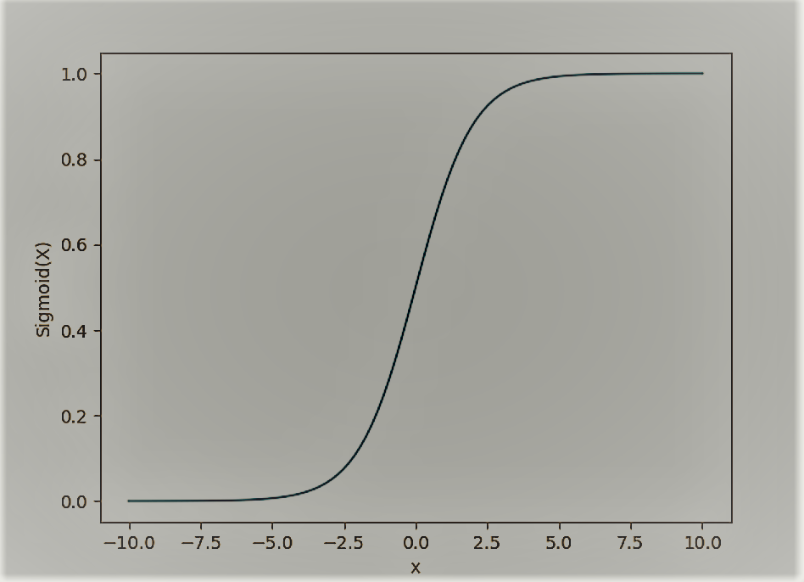

Illustration 1.

Illustration 1 shows the Sigmoid Function which is give by Sigmoid(x) = 1/(1+e^-x)

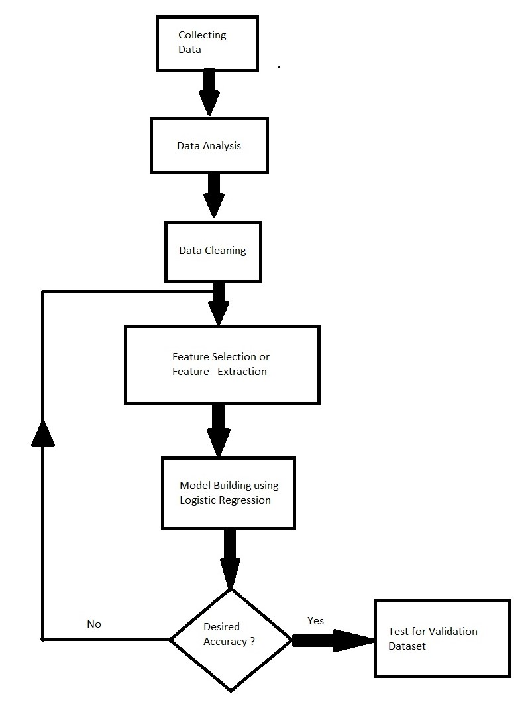

Illustration 2.

Illustration 2 shows the steps taken to build our machine learning model.

b) Preprocessing Techniques:

Below mentioned are the preprocessing techniques:

Collecting Data:

It is the process where we collect previous year data in order to train our model. The more the number of data, the more accurate our trained model will be. Here we collect the data coming from the ThingSpeak web server.

Data Analysis:

Data analysis is a way where graphs can be used to interpret certain things from the dataset. This can basically be helpful for selecting the correct features required to train our model. Libraries in python such as matplotlib, seaborn and plotly are very useful for this purpose.

Data Cleaning:

Data cleaning is a must and is done to get rid of null values, redundant values, noisy data and outliers. It is a very important step which should not be ignored since a leniency in it would cause inappropriate results.

Feature Selection:

It is a process of selecting the most accurate features that will be helpful for training our model and giving better results. It does not just depend on the features present in the dataset, but it would also rely on the process of feature extraction. In this paper we have used trial and test methods to select features.

c) Model Training:

For training the model, this paper uses Logistic Regression Classifier to predict the occurrence of floods. Feature Selection has been done by taking the data coming from the ThingSpeak web server and using feature extraction and considering the already present features from the dataset. Passing the features into the Logistic Regression algorithm trains the model based on the training data and validation data. After acquiring the required accuracy, the model is run on the test data.

After training we have used the subsequent to check how fine our model works:

I. Confusion Matrix: It is a table that is often accustomed to define the quality of a classification model on a group of validation or test data for which the true values are known. It helps us to analyze the performance of an algorithm.

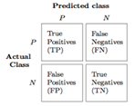

II. Precision: Precision refers to the share of your results which are apt. It is given by: True Positives / (True Positives + False Positives)

III. Recall: Recall refers to the share of total apposite results aptly classified by your algorithm. It is given by: True Positives / (True Positives + False Negatives)

Here, we are paying more attention on recall since an output that is FN(False Negative) will be more disastrous because if flooding of dam is going to occur and if the model predicts no flood occurrence then it would lead to a mishap .Recall is the only performance measure that focuses on False Negatives and hence is the best performance measure to verify our model quality.

***C. Pseudo Code*:**

The following pseudo code explains the steps taken for the completion of the project.

Step 1:

Read analog values from the below components Ultrasonic Sensor, Temperature and Humidity Sensor ,Water Flow Sensor and Water Level Sensor

Step 2:

Retrieve Previously Stored values from Cloud in an Array “PrevData”.Store New Data to the Cloud.

Step 3:

Train the model using data stored in the “PrevData” Array. Here we are using Logistic Regression to predict the possibility of flood.

Step 4:

Predicting the flood possibility for new values using the trained model.

Step 5:

Display the Values to the Dam Head office or concerned authorities. WebSite, Mobile Apps, LCD/LED Displays can be used for displaying.

**V. EXPERIMENTATION AND DISCUSSION OF RESULTS**

The occurrence of flood is predicted by our model and the results are showcased as shown below. The early prediction of the flood would inform all the concerned authorities and the people of the area that it is going to be flooded. This early prediction would minimize the flood casualties as it is being predicted prior to the occurrence there would be ample amount of time for the officials to evacuate people to more safer places or areas to ensure their safety. Prediction is considered to be valid enough because our recall score is found to be 90% which is a good score for flood prediction. Since the prediction is accurate all the required precautionary measures could be taken to reduce the loss of life due to such a massive natural disaster. The major result of our model is that it would help in minimising the destruction caused due to floods to a small percentage at least hence helping mankind.

The Illustration 3. describes the visualization of data in various tables captured at a selected time and date, and shows the chance of occurrence of Flood after applying concepts of Data mining and machine Learning.The location of the place where the occurrence of the flood is detected as shown in Illustration 4. This is done so as the person viewing the results should not be confused about which of the dams is the cause for the flood at different locations.

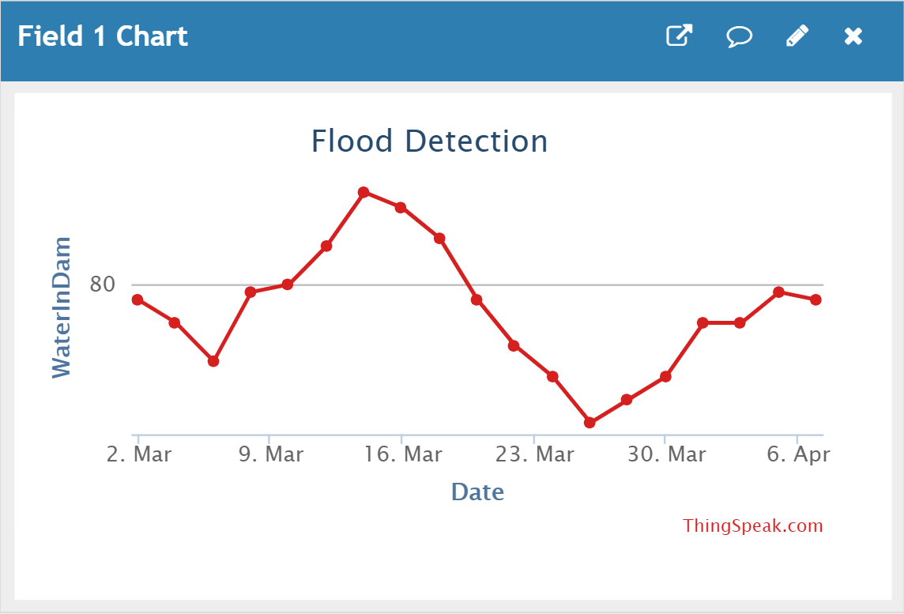

Illustration 3.

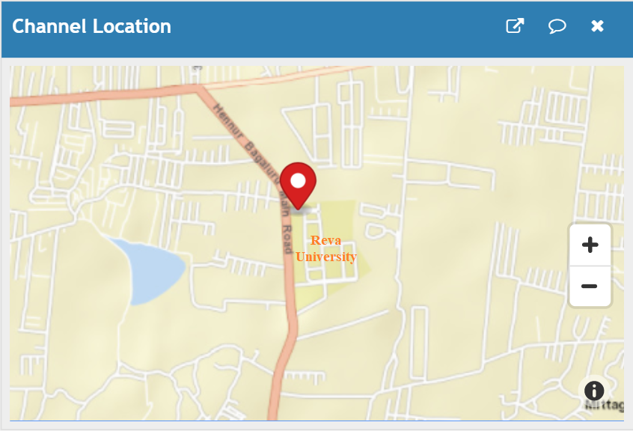

Illustration 4.

In Illustration 5, we see the correlation among the varied months’ rainfall with the rainfall occurred within the months from June to September. This is important to know which months apart from June to September play a role in predicting the occurrence of flood. In order to know the pairwise relationship among the various related features such as average rainfall in the first few days of June,increase in rainfall from May to mid of June and water level of the dam , a graph is plotted as shown in Illustration 6.

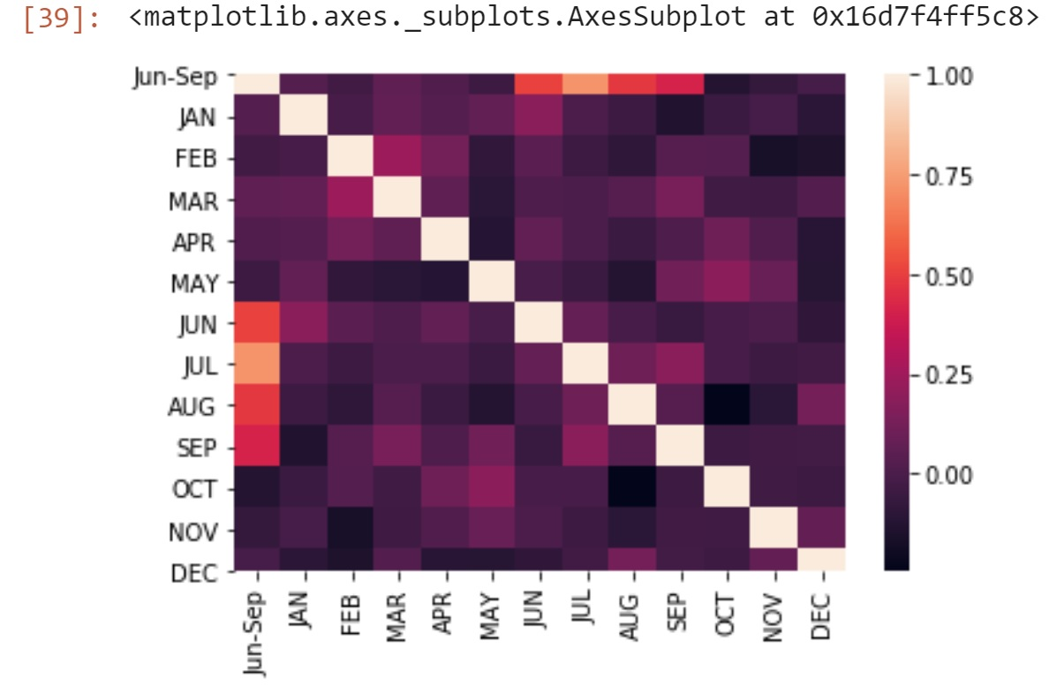

Illustration 5.

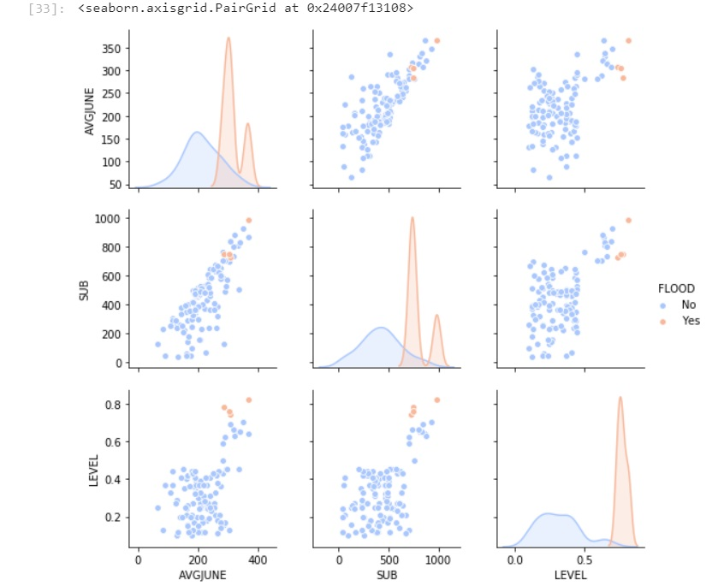

Illustration 6.

The resulting accuracy is much better than the other algorithms and thus gives proper prediction of flood occurrence in the dam.

**VI. CONCLUSION**

According to IoT concepts, if we find a sensor as an aspect of IoT that communicates its current status and allows it to be published on the Internet, then our proposal is very similar to what we plan to achieve within the Internet of Things term.

Nevertheless, the proposal's real purpose is to achieve a system for flood detection and cautioning. The software prototype achieves this project's objective by possessing the following features, such as: the system is able to periodically conduct and record the data and post it to a website by collecting sensed data from the sensors. It is concluded that this system would be useful as one of the approaches that could be introduced to minimize the amount of flood fatalities that might occur in the immediate future. The proposed architecture is hoped to be further built into a working structure that could be useful to the community.

**VII. REFERENCES**

[1]’Early Flood Monitoring System using IoT Applications’,S Vara Kumari, O Sailaja, N V S Rama Krishna, Ch Thrinisha, (IJEAT) ISSN: 2249-8958, Volume-8 Issue-5, June 2019

[2]‘FLOOD DETECTION USING IOT’, IJARIIE-ISSN(O)-2395-4396,Vol-4 Kalpesh R. Dashpute,Nilesh S. bawa, Issue-2 2018

[3]DAM WATER LEVEL MONITORING AND ALERTING SYSTEM USING IOT R.Kavitha, Jayalakshmi, Senthil Kumar.(SSRG-IJECE) Volume-5, Issue-6, June 2018

[4]‘Real Time Monitoring and Controlling of water level in dam using IoT’, Sai Sreekar, P.C.Jain,Madhur Deo Upadhayay,[2018 IEEE 8th International Advance Computing Conference (IACC)](https://ieeexplore.ieee.org/xpl/conhome/8681387/proceeding)Issued-2018

[5] ‘Implementation Of Flood Warning System Using IOT’,DevrajSheshu E, Manjunath N, Karthik S,Akash U, (IEEE)978-1-5386-5657-0/18 ,2018

[6] International Journal for Modern Trends in Science and Technology ISSN: 2455-3778 ‘Real Time Water Monitoring System using IoT ‘Volume- 04, Issue-10, 2018

[7] ‘Water Level Monitoring and Management of Dams Using IoT’ Siddula sreekar,Prem Chand Jain ( IEEE) 978-1-5090-6785-5/2018.

[8] D. Satria, S. Yana, R. Munadi, S. Syahreza, prototype of a flood monitoring program based on Google Maps, using Arduino and GSM Module, Int. Ing. Res. J. Eng. Technol., 4, 10, 1044–1047,Issued-2017

[9]“Internet of Things for disaster management: state-of-the arts and prospects,” Partha Ray, Mithun Mukherjee, Lei Shu, under Grant 61401107 and 517018, (IEEE) July 2017.

[10] International Conference on Networking Systems and Security ‘ShonaBondhu: a cloud based system to handle flashflood’, A.K.Azad, NovaAhmed, Mahmudur Rahman Khan, (NSysS), Issued,2016.

[11] ‘Pre-flood warning system based on user mobility’. ARPN Journal of Engineering and Applied Sciences ,Fateen et al, Volume-10 ISSN 1819-6608, December 2015.

[12] ‘An Intelligent and Adaptable Grid-based Flood Monitoring and Warning System’ Danny Hughes, Phil Greenwood, Florian Pappenberger, Keith Beven. UK eScience 2006 .